zsight – Tech integrations and data flows



Document ID | DigDev_ZSight_Tech_Integrations_and_Data_Flows_v1.0
Product | ZSight
Environment | All
Confidentiality Level | Internal / Restricted

Contents
1 DOCUMENT INFORMATION 3
1.1 Validation 3
1.2 Document Distribution 3
1.3 Version Control 3
2 PURPOSE & CONTEXT 4
2.1 About this document 4
2.2 Scope 4
2.3 Roles & Responsibilities 5
2.4 Terminology 5
2.5 Conventions Used 6
3 SYSTEMS IN SCOPE 7
3.1 Gating conditions 7
4 OVERALL DATA FLOW 8
5 API SURFACES 9
5.1 ZTERS API - account-specific, temporary 9
5.2 ZSight API v1 - generic 9
5.3 Tago API - device provider exchange 9
6 CONTAINER PROVISIONING 11
6.1 Entry point: the Hauler Quote 11
6.2 Provisioning sequence 11
6.3 Step-by-step reference 12
7 CONTAINER STATUS LIFECYCLE 14
8 DEVICE REPLACEMENT ON AN EXISTING CONTAINER 15
9 ONGOING ENTITY UPDATES 16
9.1 The 60-second audit-trail guard 16
10 OUTBOUND WRITE TO QUICKBASE 17
10.1 Internal events 17
11 APPENDIX A – JOBS AND COMMANDS OUTSIDE THE INTEGRATION 18
12 APPROVAL SIGNATURES 19

DOCUMENT INFORMATION

Validation
Name |  | Role | Date (dd/mm/aa)
Issued by | Oscar Rondon | Technical Writer | 22/09/2026
Verified by | Ezequiel Garcia | Developer | 22/09/2026
Approved by | Anthony Bures | Digital Development Manager | 22/09/2026

Document Distribution
Normal | Role
Oscar Rondon | Technical Writer
Anthony Bures | Digital Development Manager
Ezequiel Garcia | Developer

Version Control
Version | Date | Author | Description of changes
1.0 | 22/09/2026 | Oscar Rondon | 1st version of the functional design document for the tech integrations and data flows in ZSight.

PURPOSE & CONTEXT

About this document
This document describes the current-state technical integrations and data flows between ZSight Tech and the external systems it exchanges data with: QuickBase, used by ZTERS to run its sales and fulfilment operations, and Tago, the provider that supplies and registers the monitoring devices.
It records how a container record is created from a QuickBase Hauler Quote, how it is registered with Tago, how it progresses through its status lifecycle to installation, how subsequent changes to customers, sites, vendors and products are propagated, and what ZSight writes back to QuickBase. It also documents the rule that allows a replacement device to be installed on an existing container without losing its history.
Warning: The integration described here was built specifically for the ZTERS account and is temporary. It is expected to be replaced within approximately six months by a generic integration API available to all accounts, after which parts of this document will no longer describe live behaviour. It should be read as a record of confirmed current behaviour rather than as a target architecture, and revalidated against the platform at each release.

Scope
This document covers the integration paths in production between QuickBase, ZSight Tech and Tago for the ZTERS account, together with the API surfaces that carry them.
In scope:
- ZSight Tech, production environment (api.zsight.tech)
- QuickBase, zters.quickbase.com, limited to the five tables that participate in the integration: Hauler Quotes, Customers, Sites, Vendors and Front Loads
- ZTERS API, /accounts/zters, the account-specific surface used for container creation and update
- ZSight API v1, /v1, limited to the four entity update operations invoked by QuickBase
- Tago API, /tago, limited to Asset Registration, Service Update, their acknowledgements, and the Monitor Feed receiver
- The ZTERS integration extension, app/Extensions/Zters
- Container provisioning from Hauler Quote through to Active status, including the Tago registration handshake
- The container status lifecycle and the device replacement rule
- The single outbound write to QuickBase on installation
Out of scope:
- All accounts other than ZTERS, which have no external integration and are noted only for contrast
- Non-production environments; the integration is gated to production
- ZTERS' internal QuickBase processes upstream of the Hauler Quote, including sales, ticketing and fulfilment
- Tago's internal device, firmware and telemetry processing
- The planned generic integration API, the migration to Q, and any future per-account integrations
- ZSight application navigation and end-user procedures, covered by the ZSight User Guide (UGU)
- Geolocation and geofence evaluation, covered by the ZSight Geolocation Logic FDD
- Tago Mobile Token and Asset Reset Flow endpoints, which were not confirmed as participating in this integration
- Scheduled jobs and manual maintenance commands, which sit outside the integration contract and are listed in the appendix for inventory purposes only

Roles & Responsibilities
Role | Responsibilities
ZTERS Operations / Fulfilment | Creates and maintains Hauler Quote records in QuickBase with ticket type ZSight Installation. Assigns the customer, site, hauler, product, intended monitor and Access Code. Creates the replacement Hauler Quote when a device is swapped.
Installation Technician | Opens the work order in the ZSight mobile app using the Access Code and installs the device on the container. May install a device other than the intended monitor.
Tago / BitGear | Registers containers as assets and returns acknowledgements. Receives service updates. Reports installations and ongoing telemetry to ZSight through the Monitor Feed.
ZSight Development | Maintains the ZTERS integration extension, the three API surfaces and the internal event listeners. Owns changes to the flows described here and notifies stakeholders when behaviour changes.
ZSight Administrator / Support | Registers customers, sites and containers directly for accounts without an integration. Archives containers with a reason. Monitors failed registrations and installations.
Technical Writer | Maintains this document and revalidates it against the platform after each release affecting the integration.

Terminology
Term Used | Description
Hauler Quote | QuickBase record that initiates the integration. Despite the name it carries the hauler, the customer, the site, the product and the intended monitor.
Ticket type | Field on the Hauler Quote. Must be set to ZSight Installation for ZSight to process the record.
RID | QuickBase record ID. Stored in ZSight as the container's external reference and used to match subsequent updates.
FLID | The container name carried on the Hauler Quote. Used to identify an existing container during device replacement.
Access Code | Code entered by a technician in the ZSight mobile app to open a work order. Must differ from the existing code for a replacement to be recognised.
Container / Asset | The same object. ZSight uses both terms interchangeably; the Tago API refers to it as an asset.
Intended device | The monitor assigned on the Hauler Quote. Recorded for ZTERS' auditing; the technician is not obliged to install it.
Vendor / Hauler / Service Provider | The same entity. QuickBase calls it a hauler or vendor; ZSight calls it a service provider.
Site / Service Location | The same entity. QuickBase calls it a site; ZSight calls it a service location.
Front Load / Product | The same entity, carrying container size, content type and service days.
Webhook | An automatic call made by QuickBase to a ZSight endpoint when a record is saved, carrying the record ID.
Upsert | A single operation that creates a record if it does not exist and updates it if it does.
Asset Registration | Message sent from ZSight to Tago to register a container as an asset. Acknowledged by Tago.
Service Update | Message sent from ZSight to Tago when data relevant to Tago changes, such as pickup schedule, address or product variant.
Monitor Feed | Tago's telemetry receiver in ZSight, carrying images, events and the installation message. Renamed from Asset Feed on 16 September 2026.
ACK | Acknowledgement returned by Tago confirming the outcome of a registration or service update. Carries a status of success, warning or failed.
Tago / BitGear | The device provider. Both names are used for the same party.
Q | The ZTERS application expected to replace QuickBase as the external system in this integration.

Conventions Used
The following structures are used as recommendations.
Info: Supplementary Information

Tip: A recommendation or useful advice

Warning: A warning or important notice

Note: A notice.

SYSTEMS IN SCOPE
Three platforms exchange data. ZSight Tech sits between the other two and is the only place they meet; QuickBase and Tago never communicate directly.
System | Role | Participation
QuickBase zters.quickbase.com | External system where ZTERS runs sales, fulfilment and operational follow-up. Records originate here. | Five tables take part: Hauler Quotes, Customers, Sites, Vendors and Front Loads. Each carries a webhook into ZSight.
ZSight Tech api.zsight.tech | The monitoring platform. Holds accounts, customers, service providers, service locations, products, containers and devices. | Receives all inbound traffic, drives the Tago exchange, and performs the single write back to QuickBase. Integration code lives in app/Extensions/Zters.
Tago / BitGear | Device provider. Registers containers as assets, holds monitors and firmware, and produces telemetry. | Receives asset registrations and service updates; returns acknowledgements and the Monitor Feed. Serves every ZSight account, not only ZTERS.

Gating conditions
Every path described in this document is confined by three conditions. A record that fails any of them passes through the integration untouched.
- The account must be ZTERS. No other account participates.
- The environment must be production.
- For the write back to QuickBase, the container status must be Active.

OVERALL DATA FLOW
Figure 1 shows every path in a single view. Almost all data flows away from QuickBase; only one message flows back, described in section 10.
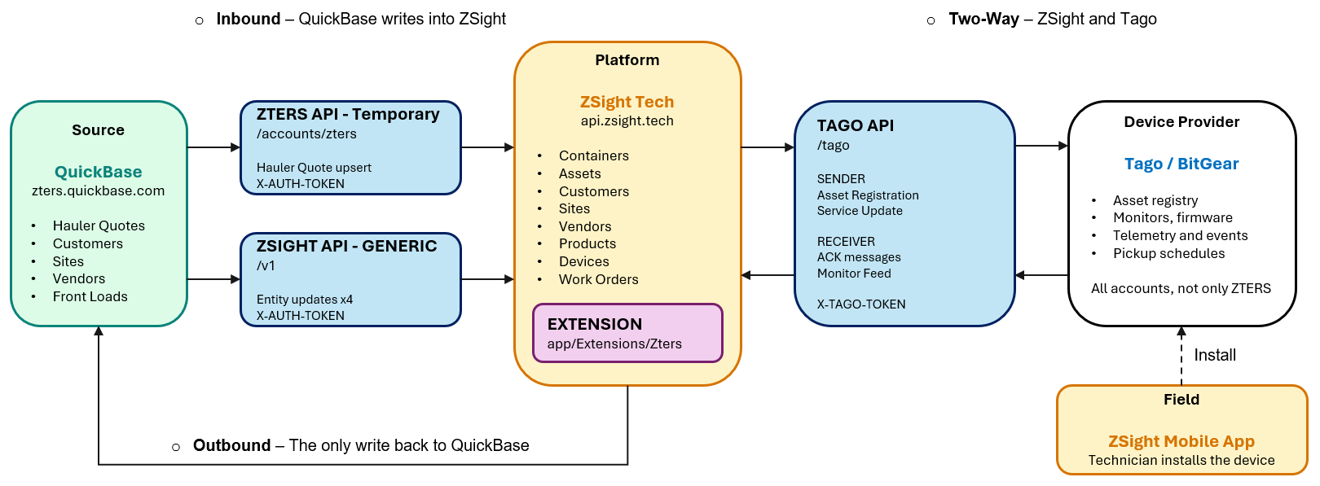
Two API surfaces carry data into ZSight. The ZTERS-specific surface exists only to create and update containers for this one account and will be retired. The generic /v1 surface is the one every future account will use. Both are described in section 5.

API SURFACES
Three API surfaces participate, each with its own base path, authentication header and audience. Confusing them is the fastest way to misread the flow.

ZTERS API - account-specific, temporary
Base path https://api.zsight.tech/docs/accounts/zters#/. Built specifically for ZTERS so that a single QuickBase webhook could pull an entire container and its relationships across in one call. Two endpoints only.
Operation | Method or path | Authentication | Payload
Get Token | POST /auth/tokens | X-LOGIN-TOKEN | Body email, password. Returns token, used as X-AUTH-TOKEN on subsequent calls.
Upserts a Container | POST /webhooks/containers/{id} | X-AUTH-TOKEN | Path parameter id is the QuickBase record ID. No body fields are specified, the record ID is all ZSight needs. Responses 200, 401, 403, 422.

ZSight API v1 - generic
Base path https://api.zsight.tech/docs/v1#/. The platform's own public API, already partially in place and intended to become the single integration surface for every account. QuickBase uses four of its update operations to keep reference data current.
System | Role | Participation
v1.customers.update | Customer | PUT /v1/customers/{customer} - customer ID or external_id
v1.sites.update | Site / Service Location | Same pattern
v1.vendors.update | Vendor / Service Provider | Same pattern
v1.products.update | Product | Same pattern

The customer update body carries name, external_id, contact_name, contact_phone and contact_email. All calls authenticate with X-AUTH-TOKEN.

Tago API - device provider exchange
Base path https://api.zsight.tech/docs/tago#/, authenticated with X-TAGO-TOKEN. Organised by direction: Sender endpoints are calls ZSight makes to Tago, and Receiver endpoints are calls Tago makes into ZSight, split between asset acknowledgements and monitor telemetry. This surface serves every account, not only ZTERS.
System | Role | Participation
Sender | - Asset Registration  - Service Update  - Mobile Token  - Asset Reset Flow | The first two. Mobile Token and Asset Reset Flow were not covered in the review session.
Receiver, Asset | - Asset Registration ACK  - Service Update ACK  - Mobile Token ACK  - Asset Reset Flow ACK | The first two.
Receiver, Monitor | - Monitor Feed | Yes, telemetry, events and the installation message.

The asset registration acknowledgement carries message_type, message_id, status, message, request_datetime, response_datetime and asset_id. The status field takes success, warning or failed.
Note: The telemetry receiver was deployed as Monitor Feed on 16 September 2026. It was previously called Asset Feed, and earlier documentation or code comments may still use the old name.

CONTAINER PROVISIONING

Entry point: the Hauler Quote
ZTERS staff take a customer request, work it through their internal fulfilment process and end up creating a Hauler Quote. The name is misleading: besides the hauler it holds the customer, the site, the product and the monitor intended for installation. When the record is saved, QuickBase fires the webhook. Nothing enters the integration any other way.
The record must be created with ticket type ZSight Installation. ZSight checks this on receipt; a hauler quote of any other type is ignored. This is what keeps ZTERS' wider ticket traffic out of the integration.
The webhook delivers only the record ID. ZSight then calls back into QuickBase to read the record and builds the full object graph from it: Account (ZTERS) → Customer → Site → Container.
From the Hauler Quote | Becomes in ZSight
Record ID, RID | The container's reference to its QuickBase record
FLID | Container name
Customer | Customer, created if absent
Site address | Site / Service Location, created if absent
Hauler | Vendor / Service Provider, created if absent
Size, content type, service days | Product, created or assigned
Assigned monitor | Intended device on the container
Access Code | The code technicians enter in the mobile app

Warning: The monitor named on the hauler quote is the device ZTERS intends to install, recorded for their own auditing and reporting. In practice a different device is frequently fitted, and the system allows it. Do not treat the assigned monitor as the installed device.

Provisioning sequence
Figure 2 shows the full sequence from the hauler quote being saved to the container reporting telemetry. Four participants take part, each passed through once.
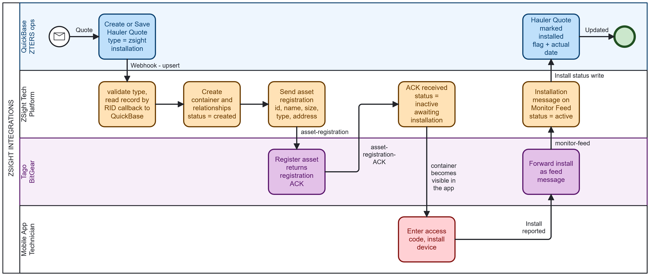
Solid arrows are sequence within a participant. Dashed arrows are messages between participants. The dotted line is availability rather than a message: nothing is pushed to the mobile app, the container simply appears once its status is Inactive.
Info: At the point the registration acknowledgement lands, the same container exists in all three systems and each holds the identifier the others use: the QuickBase record ID on the ZSight container, the ZSight asset ID at Tago, and the ZSight install flag written back onto the hauler quote. From then on QuickBase's role is limited to sending updates when something changes.

Step-by-step reference
# | Step | Actor | Mechanism | Resulting Status
1 | Hauler Quote saved with type ZSight Installation | QuickBase | Record save | -
2 | Webhook fires with the record ID | QuickBase → ZSight | POST /accounts/zters/webhooks/containers/{id} | -
3 | Ticket type validated, record read back | ZSight → QuickBase | API callback | -
4 | Customer, site, vendor, product and container created | ZSight | Internal | Created
5 | Asset registration sent | ZSight → Tago | Asset Registration | Created
6 | Registration acknowledged | Tago → ZSight | asset-registration-ack | Inactive, awaiting installation
7 | Technician opens the work order and installs a device | Mobile app → Tago | Mobile app | Inactive
8 | Installation arrives as the first feed message | Tago → ZSight | Monitor Feed | Active
9 | Install flag and actual date written to the hauler quote | ZSight → QuickBase | Event-driven write | Active
10 | Telemetry, images and events accumulate as daily feed history | Tago → ZSight | Monitor Feed | Active

CONTAINER STATUS LIFECYCLE
Status is set by the integration, not by a user, with one exception. The transitions are the acknowledgements and feed messages described in section 6.
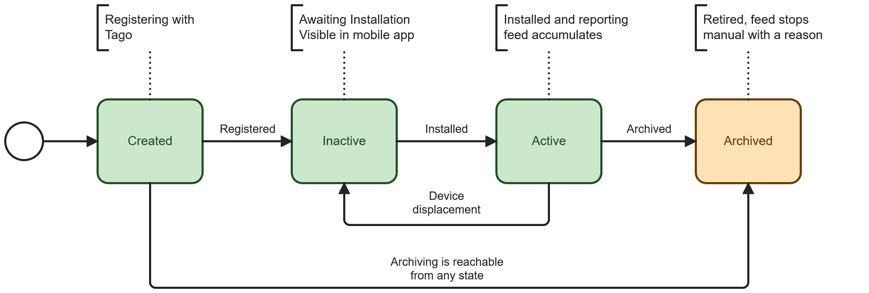
The status shown in Figure 3 is the one on the container record, not the device, the work order or the notification. Created, Inactive and Active are set by the integration. Archiving is the only manual transition, requires a reason, and is reachable from any state. The return edge from Active to Inactive is the device replacement path described in section 8.

DEVICE REPLACEMENT ON AN EXISTING CONTAINER
A monitor fails and has to be swapped. The container itself stays, because it already carries daily feed history, notifications and service records that would be lost if a new container were created. ZTERS therefore creates a new Hauler Quote in QuickBase carrying essentially the same information, and three fields decide whether ZSight interprets it as a replacement.
# | Field on the new Hauler Quote | Required value | Purpose
1 | Ticket type | ZSight Installation | Admits the record to the integration at all
2 | FLID, container name | Identical to the existing container | Identifies which container is being re-serviced
3 | Access Code | Different from the code on the existing container | Distinguishes a replacement from an edit to the original installation
4 | Monitor | The replacement device | Becomes the new intended device

If all three conditions hold, ZSight moves the existing container out of Active and back to pending installation when the webhook fires. The technician can then install the replacement device against the same container and the provisioning sequence repeats: Tago reports the install, ZSight returns the container to Active, and the install flag and date are written to the new hauler quote as though it were a first installation.

ONGOING ENTITY UPDATES
After provisioning, QuickBase's only role is to notify ZSight when something changes. ZSight's job is then to decide whether Tago needs to know.
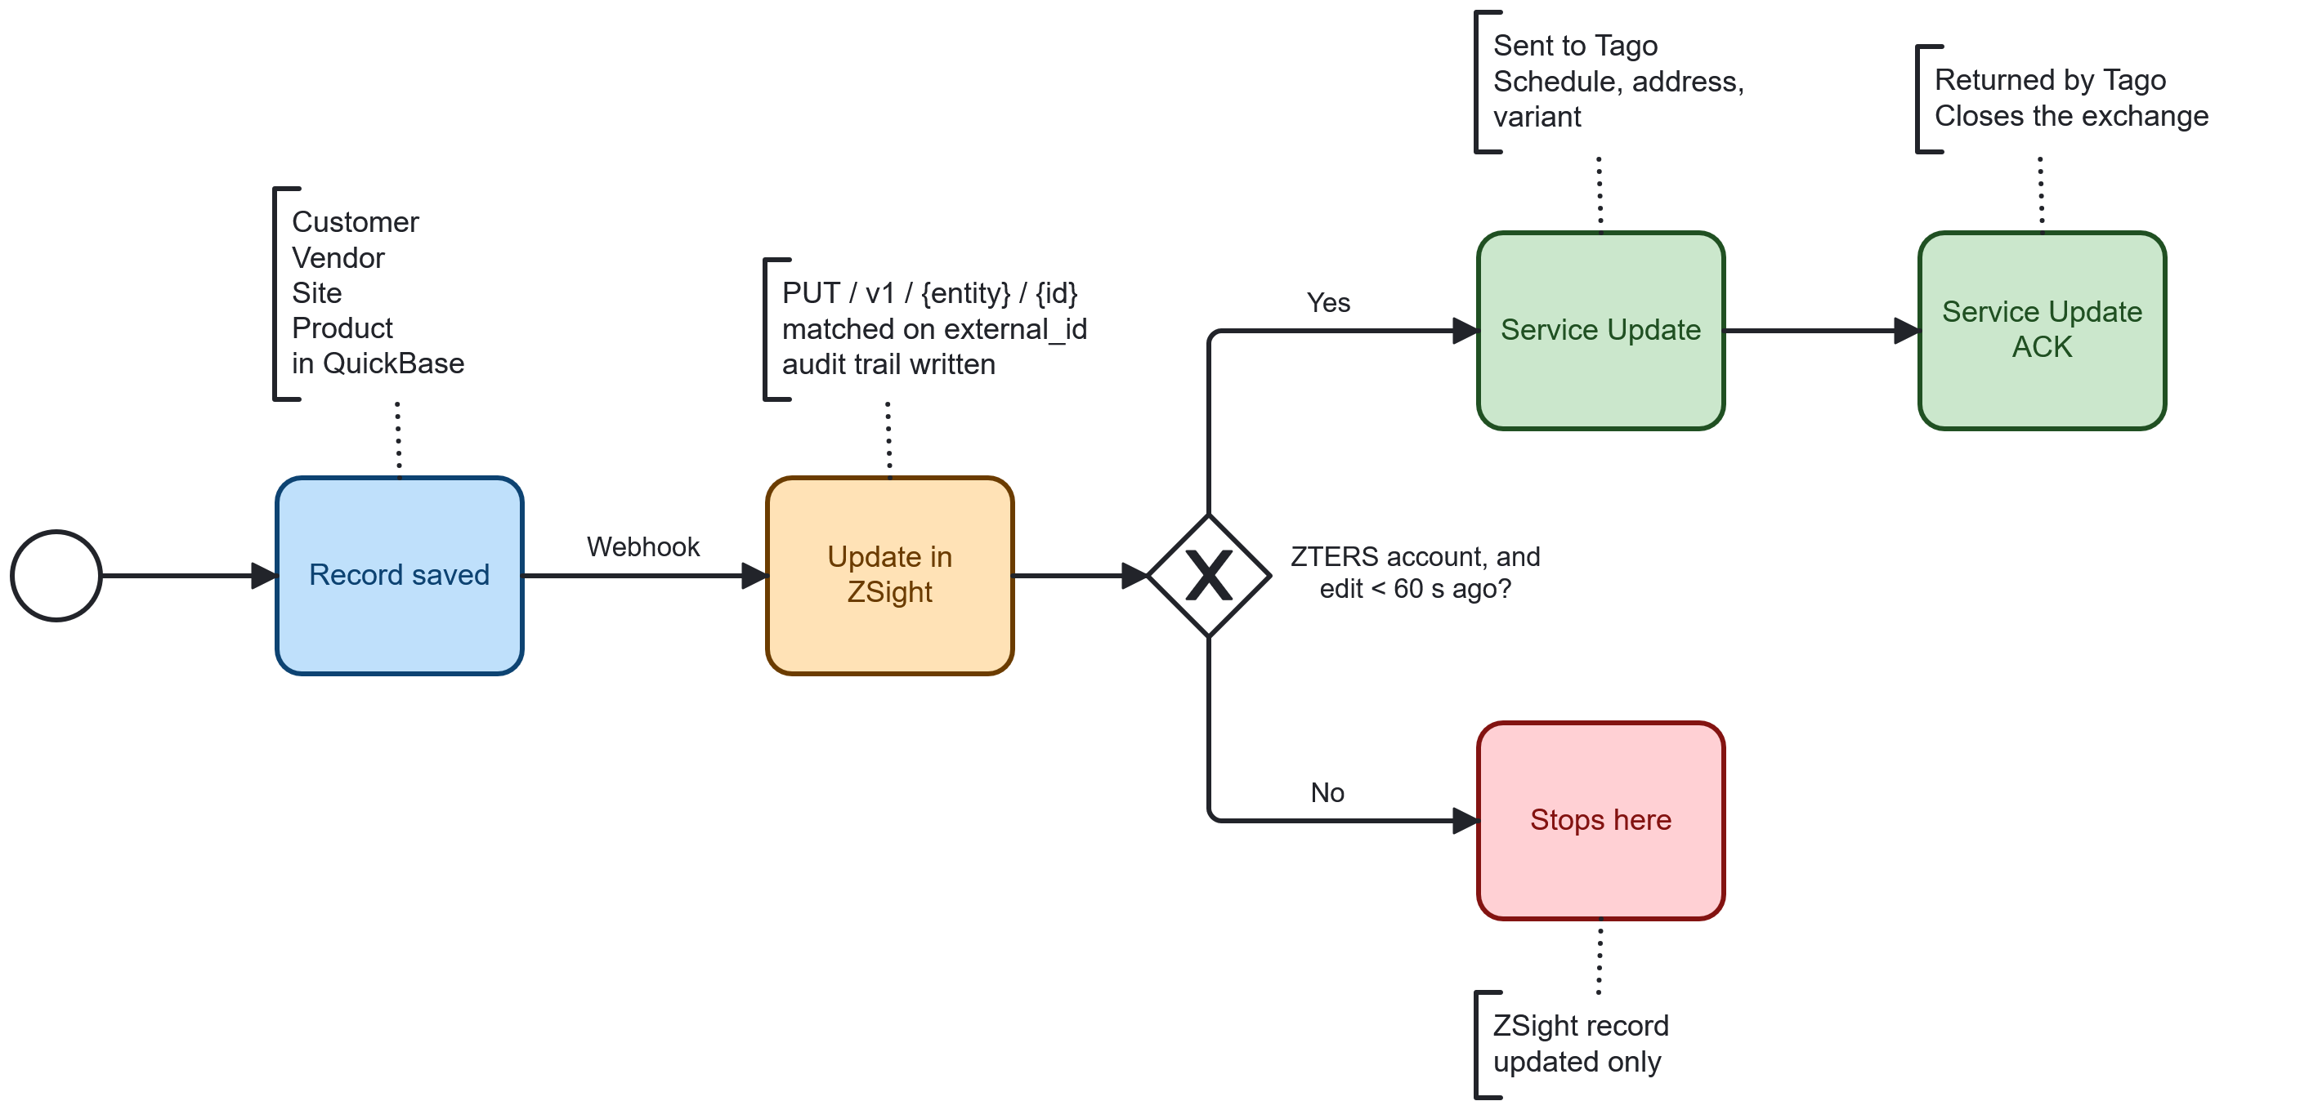
Four entities follow this path: Customer, Vendor, Site and Product. The generic /v1 endpoints identify the ZSight record by its external_id, which is the QuickBase record ID captured at provisioning, so the update lands on the right row without QuickBase needing to know ZSight's internal identifiers.

The 60-second audit-trail guard
ZSight writes an audit trail entry every time QuickBase updates data. Before sending a service update to Tago, the extension confirms two things: that the container belongs to ZTERS, and that the audit trail shows the edit was made by the ZTERS integration account within the last 60 seconds. The account is held on an allow list.
The effect is that only changes which genuinely originated in QuickBase are propagated onward to Tago. An edit made by a person inside ZSight updates the ZSight record but stops there.
Change | Originating entity | Why Tago needs it
Pickup schedule | Product | Determines when collection is expected, used in Tago's reporting
Address | Site | Location of the registered asset
Asset | Container | Identity and naming of the registered asset
Variant | Product | Size and content type of the container

OUTBOUND WRITE TO QUICKBASE
One message, two fields, once per installation. This is the entire write surface in that direction.
When the installation arrives from Tago and the container moves to Active, ZSight writes two fields onto the corresponding Hauler Quote: zsight_install_completed, a completion flag, and zsight_actual_install_date, the actual installation date. QuickBase holds a projected install date of its own, which ZSight does not touch.
Warning: Only installation is written to QuickBase. When a container or device is removed, nothing equivalent is sent. This part of the process is acknowledged as currently disconnected while the platform is in transition.

Internal events
Three listeners in the ZTERS extension carry the flows described above. They are listed here under the names used in the code.
Event | Fires when | Condition | Action
AssetImport | A Hauler Quote is imported or updated | Is the asset already registered with Tago? | Not registered → Asset Registration. Already registered → Service Update. Tago acknowledges either way.
AssetInstallation | Tago reports an installation, having been notified by the mobile app | The container belongs to the ZTERS account | Writes the two installation fields to QuickBase
ProductUpdated | A customer, vendor, site or product is updated | ZTERS container, and the audit trail shows a ZTERS-account edit within 60 seconds | Service Update to Tago

APPENDIX A – JOBS AND COMMANDS OUTSIDE THE INTEGRATION
This appendix is recorded for the audit requirement in DIGDEV-62498. An earlier revision of the integration map presented these processes alongside the webhooks. They were subsequently identified as custom data-maintenance work that sits outside the integration proper and will be deleted along with the ZTERS extension.
Process | Type | What it does
sync-products --service-update | Cron, daily 04:00 | Re-reads product size, content type and pickup days from QuickBase. Changed records also ping Tago, throttled at 0.5 s intervals.
import-records | Manual | Runs the hauler quote pipeline in bulk. Described as no longer in routine use.
sync-asset-products | Manual | Re-links an asset to its product; optionally pings Tago afterwards.
import-installation-photos | Manual | Copies placement photos from the QuickBase file store into Azure Storage and links them to the asset.
export-installation-status | Manual batch | Performs the section 10 write by hand across installed ZTERS assets instead of waiting on the event.

APPROVAL SIGNATURES
Digital signature blocks below are formatted for DocuSign / Adobe Sign.
Name | Role | Digital Signature Block | Date (dd/mm/aa)
Approval’s name | Approval’s role |  | 22/09/2026

